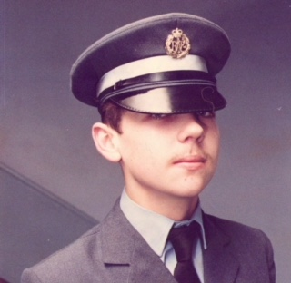
My name is Kevin O’Brien and I am a former member of the Royal Air Force and I served in the RAF throughout the 1980’s, a period known as “the Cold War”.
After my service, adjusting to civilian life was difficult at times, with no-one to speak to or anyone who understood the stress and strain of the work we as servicemen/servicewomen undertook during a very secretive era in military history. As well as the loss of comradeship and banter that can only be found in the armed forces.
I have recently started to visit the Trafford Veterans Breakfast club, and have found it a place to discuss the old days and relive days gone by. I have also found it a place where people of the same age as me, and faced the same difficulties as me, can get together and work through our problems as a team once again.
The support, the suggestions I have been offered, and the help and guidance on hand is fantastic. I am glad I have found them, even after this long.

